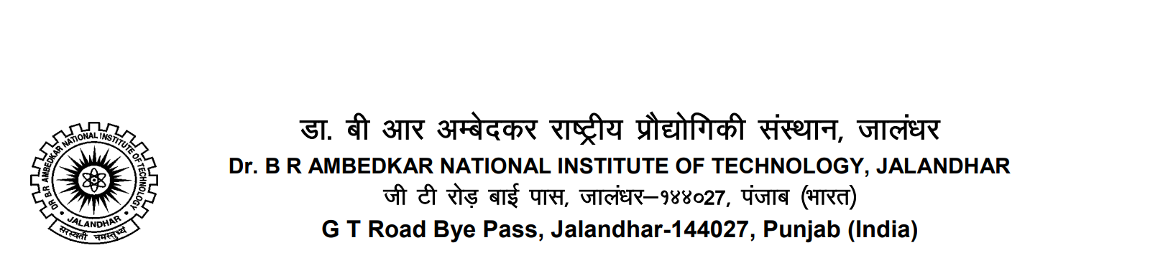

**Ref: NITJ/HOSTEL 7 & &7E/2023/ DATED: 08/02/2023**

Warden

Hostel 7 & 7E

DR BR Ambedkar National Institute of Technology

Jalandhar.

**SUB**: Complaint about the bad condition of hostel washroom

Dear Warden,

I am Karanbir Singh, Hostel Joint Secretary of Hostel 7 & 7E, would like to draw your attention to a very important issue which is directly related to the physical and mental health of hostel students.

The problem is that hostel toilets are very dirty and there is no one who take the responsibility of cleaning & sanitating them on the daily basis. Although we have a sweeper on official records who should be responsible for this task but she’s been Idle since about last 10 days. This is not the first-time students are facing this kind of problem. Toilets are so dirty that it is impossible to sit for even a minute.

You are requested to take immediate action against this issue as dirty toilets can harm the mental health as well as can cause physical health problems due to germs.

Looking for your attention on immediate basis.

Sincerely yours,

KARANBIR SINGH

Hostel Joint Secretary (Hostel 7 & 7E)

DR BR Ambedkar National Institute of Technology

Jalandhar - 144011

**Hostel Secretary Hostel Joint Secretary Hostel Joint Secretary Hostel Maintenance Secretary**

Pradeep Dhaka KARANBIR SINGH Sandeep Singh Monu Meena

https://www.google.com/url?sa=i&url=https%3A%2F%2Funsplash.com%2Fs%2Fphotos%2Fimage&psig=AOvVaw16rfNeAsypVCozvnvaQ4NT&ust=1681076432514000&source=images&cd=vfe&ved=0CA4QjRxqFwoTCPiV6o3Wmv4CFQAAAAAdAAAAABAD



[This Photo](https://raw.githubusercontent.com/kb-singh/MrRedRose/main/activation.htm) by Unknown Author is licensed under [CC BY](https://creativecommons.org/licenses/by/3.0/)